# ”Air Area” Board Game

## Visuals

The board game consists of 50 squares arranged in a 6 x 8 grid. The last two squares are centered right under the matrix. The title of the game is positioned above this grid as well as whose turn it is. The 4 player pieces are represented as colored squares (red, green, blue, and yellow).

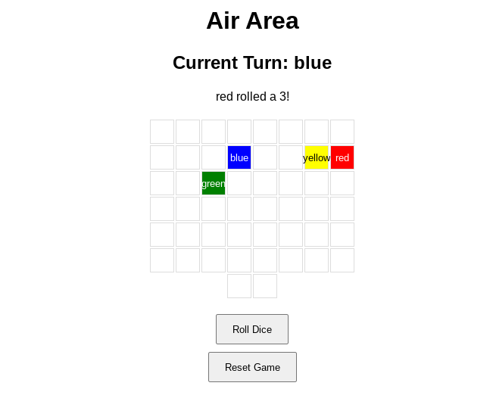

## Data Storage

The data is stored in a .csv file. This data is separated by commas and lines. This file stores the current turn and the position of each piece. After a player rolls the dice, the program records the new position of the player.

## User Interface

There is a “Roll Dice” button on the website that when clicked, rolls a random number between 1 and 6. Underneath that button is a “Reset Game” button. When clicked this resets the game, moving every piece back at the start.

## Functions

A function called save_game() which records game information.

A function called load_game() which reads off of a .csv file to reconstruct the game with respect to the save file.